National Indigenous People’s Day 2018 Celebrations
Royal Roads University, Victoria BC – June 21st, 2018

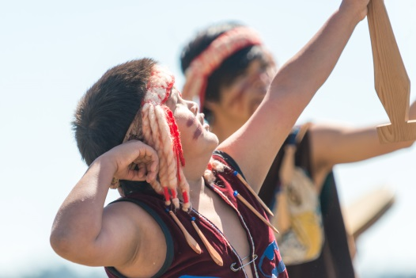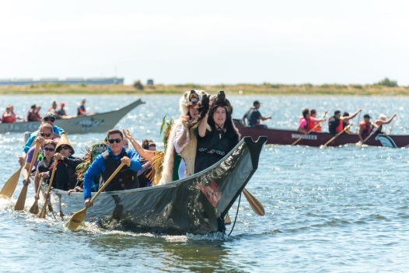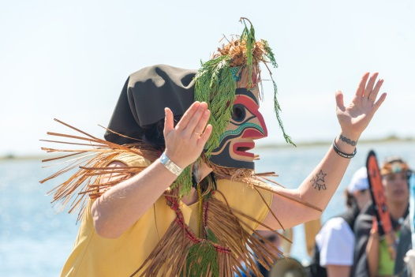

Thank you for answering our call out for volunteers!
Recently, Royal Roads University’s Indigenous Education and Student Services sent a call out looking for passionate, self-motivated and energetic volunteers to be a part of our National Indigenous People’s Day 2018 celebrations on the shores of Esquimalt Lagoon and we are very grateful for your response. Every year, Royal Roads University hosts a National Indigenous People’s Day event, featuring canoe challenges, performances, traditional foods, and more! This event would not be possible without the assistance from passionate community members like you!

Volunteer Roles

We have a wide variety of roles for all levels of Volunteering, with flexible shifts available! Please have a look at the positions available, and let us know which position(s) that would best suit your unique skill sets and goals! While we may not be able to accommodate every request, we will do our best to consider your preferences.

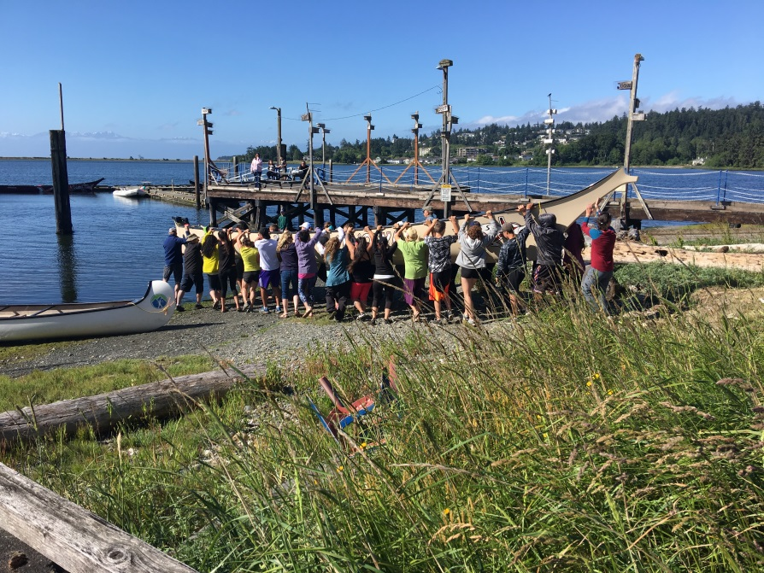
Photo retrieved from IESS National Indigenous Peoples Day 2017

Canoe Assistants - 15+ people needed
This position is ideal for individuals who are interested in canoe protocols, who are physically capable to lift up to 50 lbs, and who are able to work as a team. They should be available for multiple dates in June (see below!)
Duties will include:
- Volunteers will need to assist with lifting canoes to and from trailers to the beach at the beginning of the event and back onto trailers at the end of the day. (approx. 20ft)
- Volunteers will need to be in close proximity to where canoes are docked along the wharf.
- Volunteers will have to follow orders and requests from leaders and skippers.
- Volunteers must have closed shoes (runners, water shoes, and/or boots) and a change of clothes at hand, as you may have to be up to knee height in the water.
Volunteer Dates: Friday, June 15th 2:00pm – 4:00pm Volunteer Orientation
Thursday, June 21st 9:00am-4:00pm
Canoe Practices: Monday, June 11th 5:00pm – 7:00 pm ANSWER Drum Group Rehearsal
RRU Team Practice date & time – TBD
NIPD Hours: Arrive at 9:00 am and expect to be here assisting until approximately 4:00pm
We would appreciate any or all volunteers who are able to stay and assist with clean up at end of day!

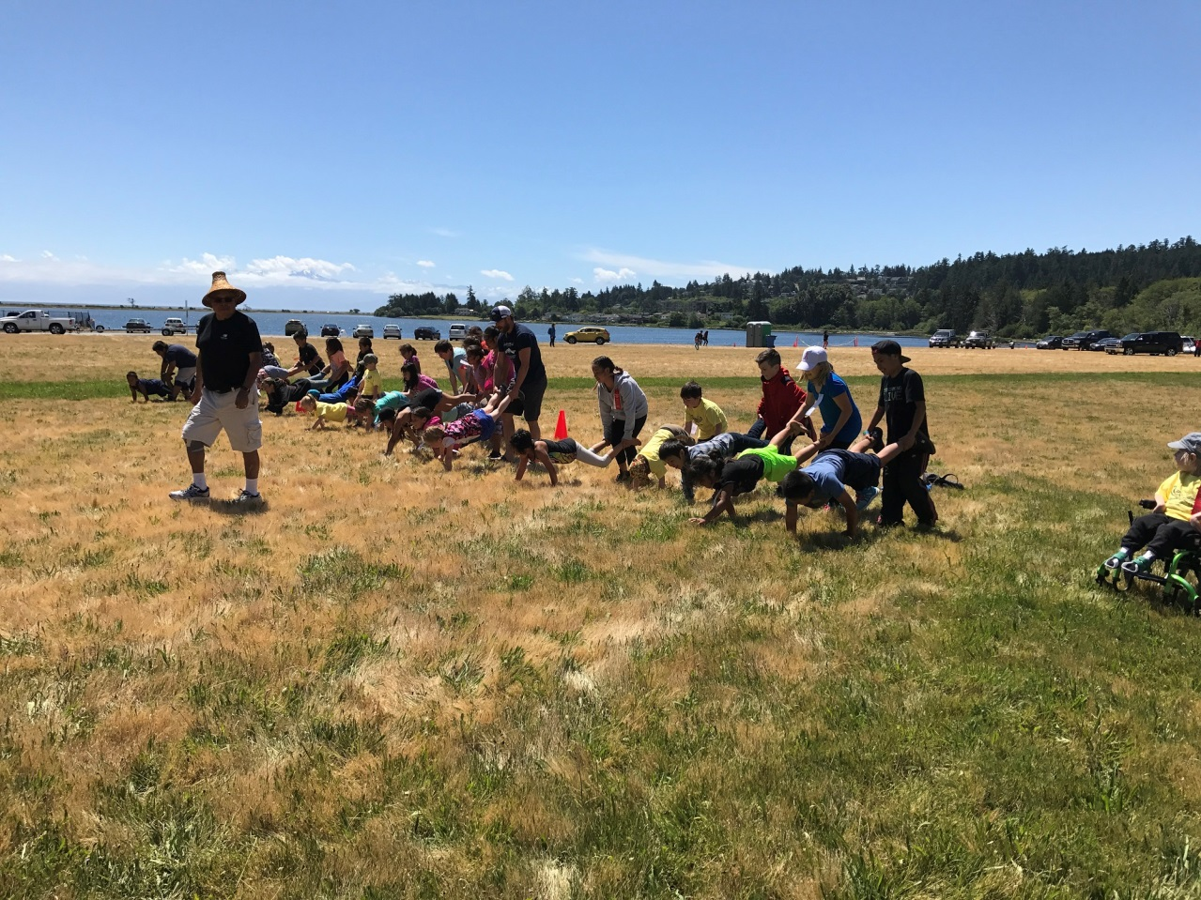
Butch Dick, one of RRU’s Heron People. Photo retrieved from IESS National Indigenous Peoples Day 2017

Field Games Assistants -5 people needed
This position is ideal for individuals who enjoy working with youth and love sports.
Duties will include:
- Assisting the Field Games leader, elder Butch Dick, as he requires, as well as the ISPARC coaches.
- Helping determine winners (linesperson)
- Refreshing fruit and water for youth
- Handing out participant ribbons, etc.
- Volunteers must wear running shoes

NIPD Hours: Arrive at 9:00 am and expect to be assisting on fields from 12pm-2:30pm

We would appreciate any or all volunteers who are able to stay and assist with clean up at end of day!
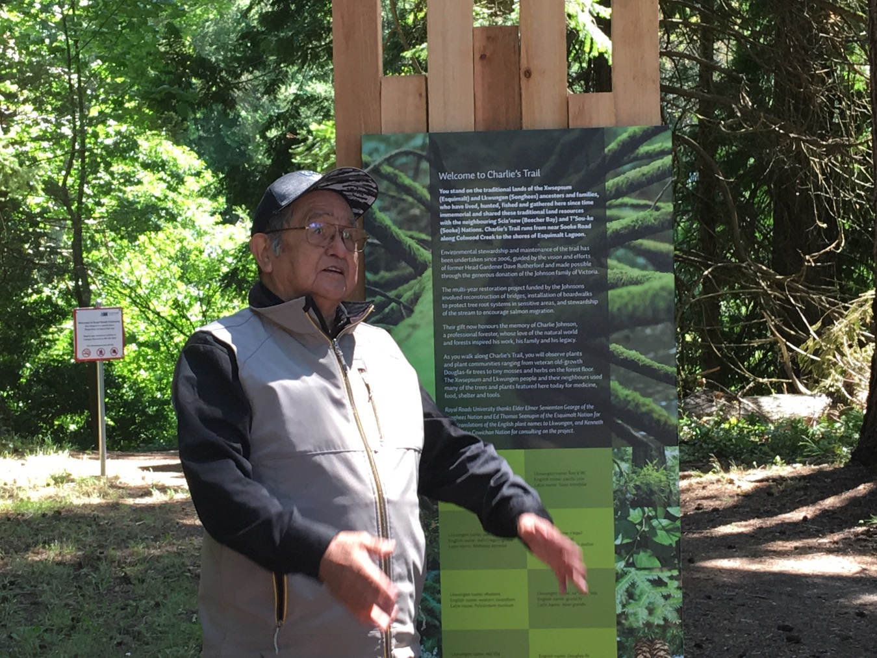
Elmer George, one of RRU’s Heron People. Photo retrieved from IESS National Indigenous Peoples Day 2017.

Charlie’s Trail Nature Walk Assistants – 2-4 people needed

This position is ideal for individuals who are interested in learning more about the history of the land, and Indigenous plants.
Duties will include:
- Assisting elder Kenneth Elliott in guiding participants through the trail
- Ensuring that guests know when and where the trail tours will be happening
- Coordinating with transport and/or elder care to resolve any accessibility issues
- Volunteers must wear appropriate footwear for walking trails –No flip flops!!
NIPD Hours: Arrive at 9:00 am and expect to be assisting on the trail from 11:30am-2:30pm

We would appreciate any or all volunteers who are able to stay and assist with clean up at end of day!
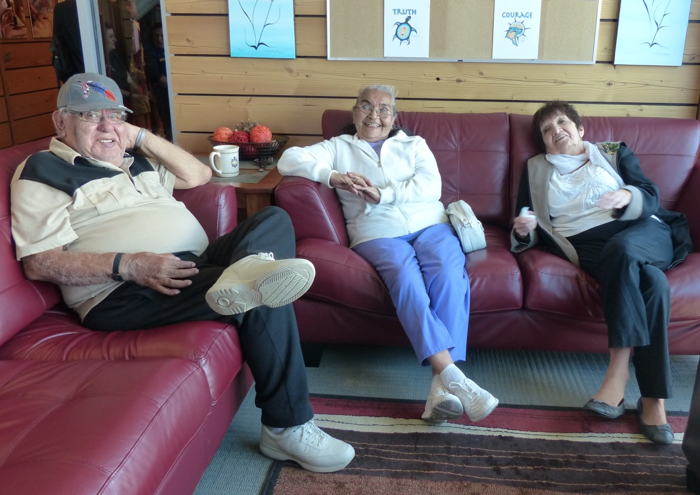
Burt & Lee Charles, Shirley Alphonse, three of RRu’s Heron People. Photo retrieved from IESS National Indigenous Peoples Day 2016

Elder Care - 9-10 people needed

This position is ideal for individuals who value creating accessible spaces for all members of community.
Duties will include:
- Being of general assistance to the elders who will be in attendance and who utilize the elders’ room [area to be determined].
- Ensuring water is replenished asking elders if they want tea/coffee/juice/snacks/etc.
- Ensuring that elders know what activities are going on throughout the day
- Connecting with Golf Cart/ Transportation to make sure elders can access activities elsewhere on campus.
NIPD Hours: Arrive at 9:00 am and expect to be assisting in the elders’ room from 10:00am-3:00pm, 10:00am-1:00pm, or 12:30pm-4:00pm

We would appreciate any or all volunteers who are able to stay and assist with clean up at end of day!

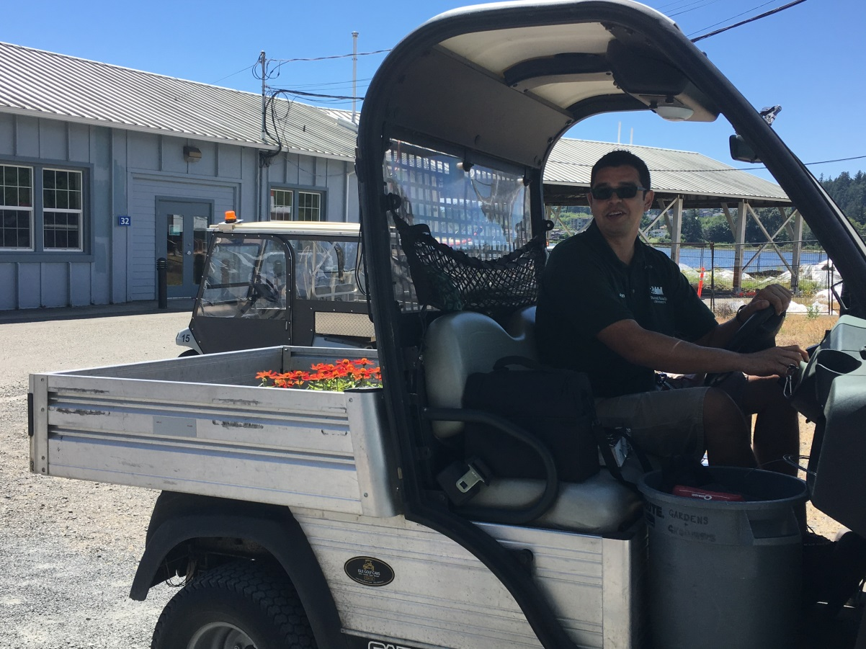
John Kwaksistala. Photo retrieved from IESS National Indigenous Peoples Day 2016

Golf Cart/Transportation - 4-5 people needed

This position is ideal for individuals who have already received golf cart training by Royal Roads.
Duties will include:
- Transporting guests who need assistance/special guests/elders to and from event locations.
- Having a good understanding of traffic routes on campus is a must.
- Maintaining regular communication with NIPD Volunteer coordinator, Lauren.
NIPD Hours: Arrive at 9:00 am and expect to be assisting from 9:00am-4:00pm, 9:00am-1:00pm, or 12:30-4:00pm

We would appreciate any or all volunteers who are able to stay and assist with clean up at end of day!
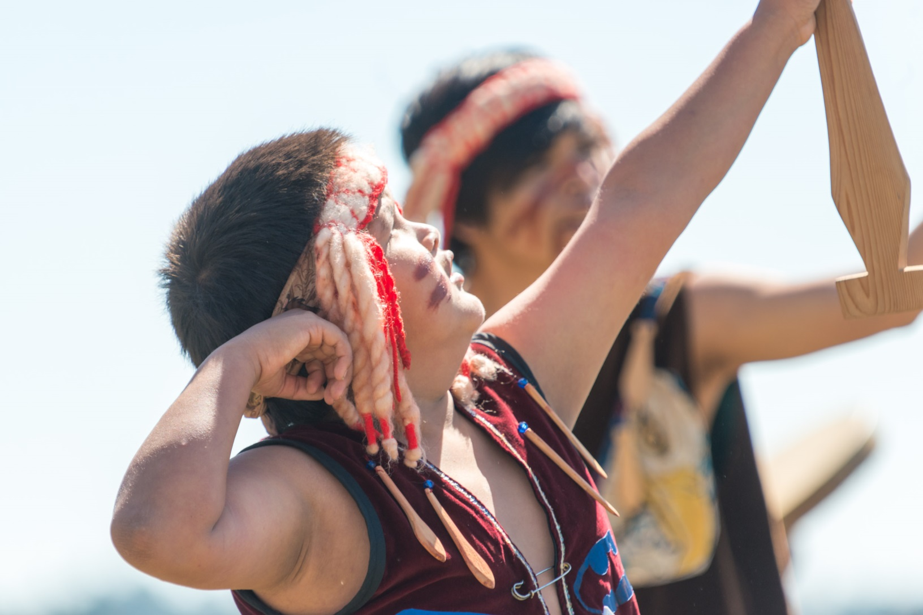
Esquimalt Drummers & Singers. Photo retrieved fromRRU’s Media Services - IESS National Indigenous Peoples Day 2017

Performer Assistants - 3 people needed
This position is ideal for individuals who have a passion for indigenous arts and culture!
Duties will include:
- Ensuring the performers and MC have everything they need leading up to, and following their performances.
- Providing water & snacks to performers & MC
- Helping to carry any items
- Ensuring performers make it to transport buses when necessary
NIPD Hours: Arrive at 9:00am and expect to be here assisting from 10:00am- 3:30pm, 10:00am-12:30pm, or 12:00-3:30pm

We would appreciate any or all volunteers who are able to stay and assist with clean up at end of day!
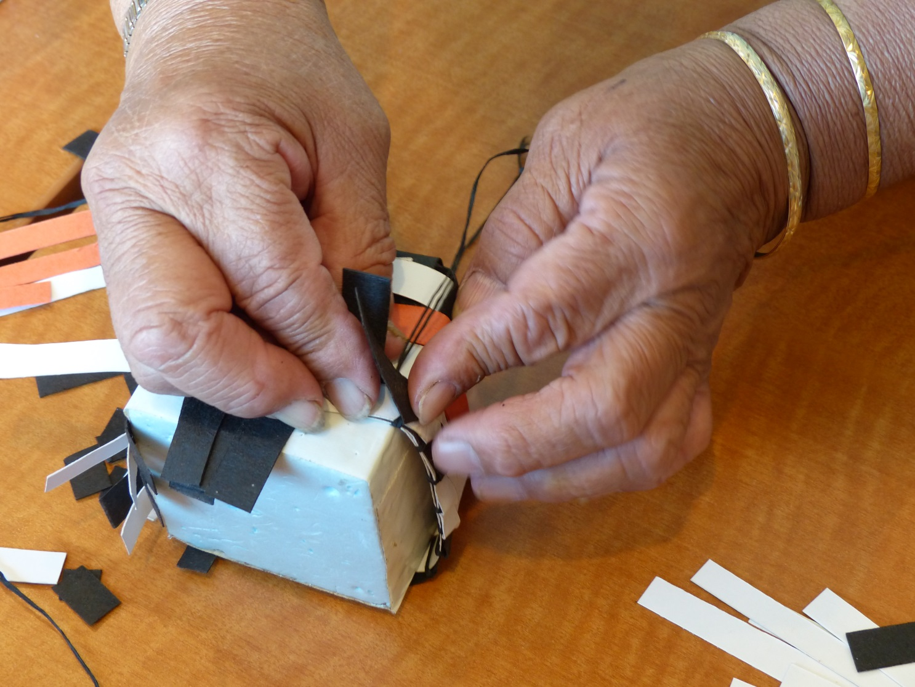
Photo retrieved from IESS National Indigenous Peoples Day 2016

Craft Facilitators - 4 people needed

This position is ideal for creative individuals who are passionate about learning more about Indigenous art, and interacting with youth.
Duties will include:
- Ensuring all craft tables are set up before youth arrive
- Ensuring tables are stocked with necessary supplies
- Maintaining order while activities are ongoing
- Facilitating youth as they create miniature drums, medicine bags, etc.
- Cleaning up the stations when activities are finished
NIPD Hours: Arrive at 9:00 am and expect to be here assisting until approximately 4:00pm

We would appreciate any or all volunteers who are able to stay and assist with clean up at end of day!
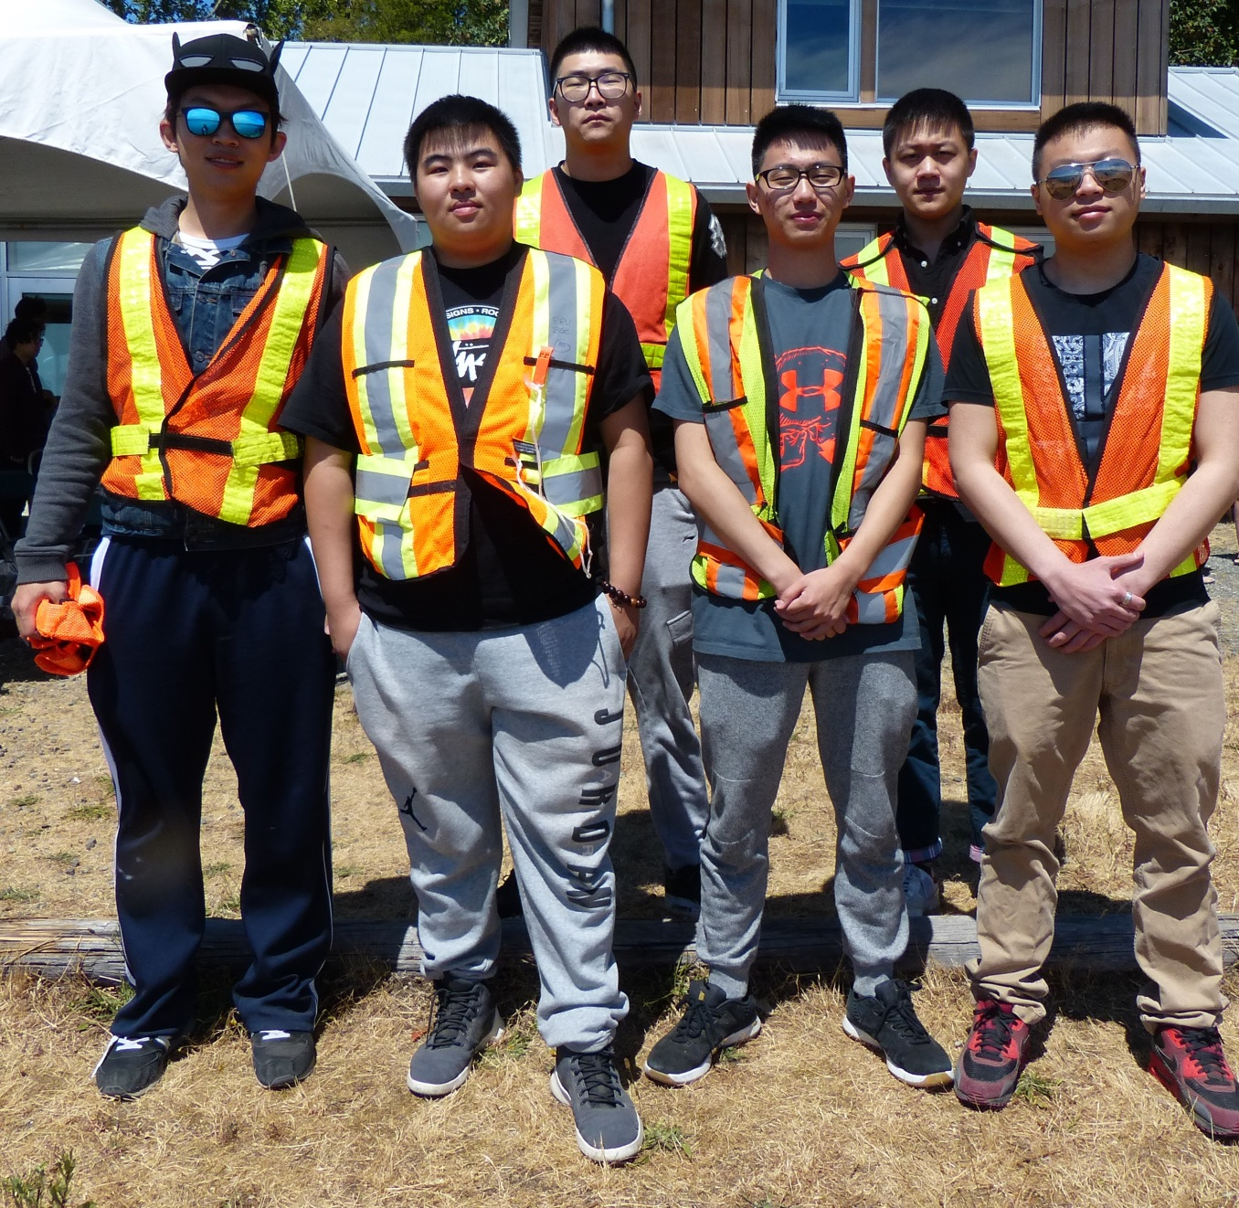
International Student volunteers. Photo retrieved from IESS National Indigenous Peoples Day 2017

Traffic Control - 2-3 people needed

This position is ideal for individuals who are confident, calm, and comfortable directing a high volume of guests.
Duties will include:
- Assisting the Commissionaires to ensure the proper and safe flow of traffic through to the general parking area
- Redirecting overflow parking to other lots
- Ensuring safety of Nature Walk participants at the head of Charlie’s Trail
- Directing new participants to and from the shuttle drop off locations
- Providing information to guests arriving on shuttle, ie. Map of venue, schedule of events, etc.
NIPD Hours: Arrive at 9:00 am and expect to be assisting Commissionaires from 9:15 am-11:00 am & 2:00pm – 3:00pm

We would appreciate any or all volunteers who are able to stay and assist with clean up at end of day!

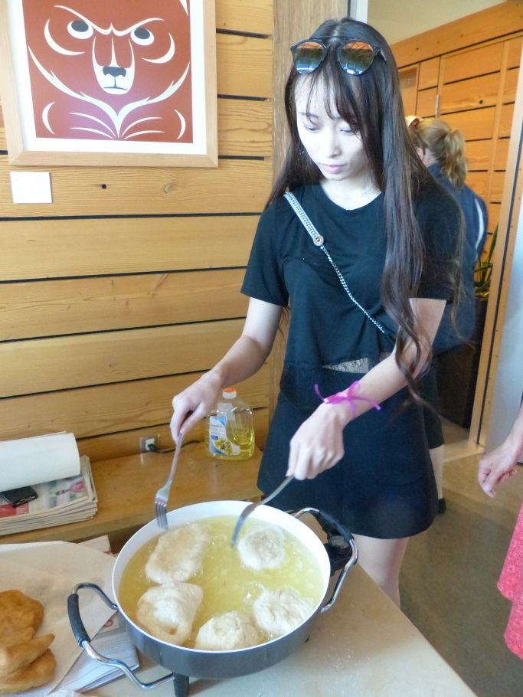
International Student Volunteer. Photo retrieved from IESS National Indigenous Peoples Day 2016

Catering Support - 4 people needed

This position is ideal for individuals who love fry bread!
Duties will include:
- Assisting the event caterer, Jessica Sault, as needed
- Unloading/loading catering supplies/food
- Frying bread
- Washing dishes & utensils as necessary
- Ensuring there is fruit prepared for the field games and craft stations
NIPD Hours: Arrive at 8:00 am and expect to be assisting from 8:30-3:00pm, 8:30-12:30pm or 12:00-3:30pm

We would appreciate any or all volunteers who are able to stay and assist with clean up at end of day!

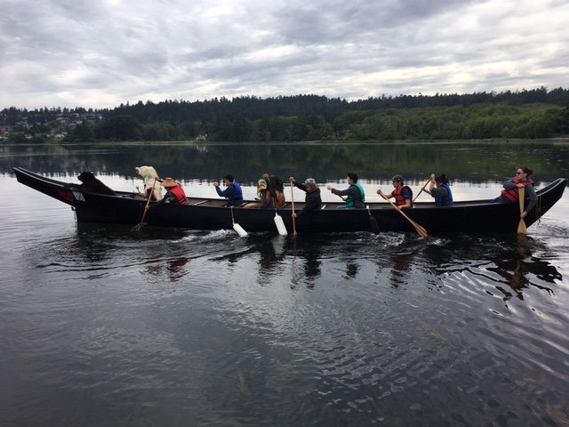
ANSWER Drummers & Singers practice. Photo retrieved from IESS National Indigenous Peoples Day 2017

General Support

This position is ideal for individuals who think all positions look great and just can’t decide!
Don’t worry if you’re indecisive, or only have a short time to volunteer. We will find something amazing for you to do!
NIPD Hours: Arrive at 9:00 am and expect to be here assisting until approximately 4:00pm
We will need lots of support in preparing craft materials prior to the day of the event, so if you are interested in stopping by and sharing a few hours of your time Monday to Friday, from now until June 20th, email Lauren your availability at lauren.petersen@royalroads.ca

Please note a mandatory volunteer orientation will take place Friday, June 15th, 2018 at 2:00pm.
Additionally, we will be holding a separate volunteer appreciation lunch to express our gratitude for your invaluable contributions to our NIPD celebrations.

Application to Volunteer
We are grateful for any and all community members willing to make National Indigenous People’s Day a success.
Name:
Email:
Phone:
Volunteer Position preference (Please check all that apply)
Canoe Lifters/ Assistants Field Games Charlie’s Trail Nature Walk
Elder Care Traffic Control Golf Cart/ Transportation
Performers Assistance Catering Support General Support
Times Available (Please check all that apply)
9:00 am to 1:00 pm 9:00 am – 11:00 am 9:30 am – 12:30 pm
10:00 am – 12:30 11:00 am – 1:00 pm 11:00 am – 2:30 pm
12:00 pm – 2:30 pm 12:30 pm – 3:00 pm 2:00 pm – 3:00 pm

Please Note a mandatory volunteer orientation will take place Friday, June 15th, 2018 at 2:00pm
Additional Questions, Comments, or Necessary Accommodations?

Please return the signed form back to RRU’s Indigenous Education & Student Services by email by June 8th, 2018.
Email: lauren.petersen@royalroads.ca

